**SERVICE NETWORK PLATFORM FOR COMPANIES AND PROFESSIONALS**

**BY**

**CHIMA-OKEREKE HECTOR AMARACHI 21/1700**

**A PROJECT WORK SUBMITTED IN PARTIAL FULFILMENT OF THE REQUIREMENTS FOR THE AWARD OF BACHELOR OF SCIENCE B.Sc. (HONS) IN COMPUTER SCIENCE**

**SUBMITTED TO:**

**THE DEPARTMENT OF COMPUTER SCIENCE SCHOOL OF COMPUTING AND ENGINEERING SCIENCES**

**BABCOCK UNIVERSITY, ILISHAN-REMO**

**OGUN STATE, NIGERIA**

**APRIL 2025**

**DECLARATION**

We declare that this project titled “**Service Network Platform For Companies And Professionals”** was carried out by;

__________________________ __________________________

CHIMA-OKEREKE HECTOR AMARACHI DATE

21/1700

**CERTIFICATION**

We certify that this project was carried out by the under listed students under the supervision of the department of computer science , School of Computing and Engineering Sciences, Nigerian higher education institutions, Ilishan-Remo, Ogun State, Nigeria.

Chima-Okereke Hector Amarachi 21/1700

__________________________ ___________________________

DR. SEUN EBIESUWA DATE

__________________________ ___________________________

EXTERNAL SUPERVISOR DATE

__________________________ ___________________________

DR. SEUN EBIESUWA DATE

(HEAD, DEPARTMENT OF COMPUTER SCIENCE)

**DEDICATION**

This project is dedicated to our Lord and personal savior Jesus Christ, who made every provision possible for us to attain this academic level.

**ACKNOWLEDGEMENT**

We sincerely want to convey our deepest appreciation to the Almighty God for his grace, and to everyone who has helped or contributed in any way to the successful completion of our project. We would like to express our gratitude to our project supervisor, Dr Seun Ebiesuwa, who not only oversaw our project despite his other pressing obligations, but who also carefully read the entire script and provided helpful suggestions and support.

We would like to thank our parents, Mr. & Mrs. Chima-Okereke and my siblings for helping to make our education enjoyable by providing both financial and moral support. We will always be grateful to our parents, family members, and lecturers for their unwavering support while we conducted this research and pursued our academic goals.

**ABSTRACT**

The rapid growth of the freelance economy has created the need for a secure and structured platform that facilitates seamless interactions between companies and professionals. This project presents ProConnect, a web-based service network designed to address key challenges such as skill verification, job continuity, work tracking, and payment security. The platform allows companies to post jobs, hire verified professionals, track work hours, and process payments securely, while professionals can apply for jobs, log working hours, and request payments. Built using Node.js, Express.js, Embedded JavaScript (EJS), Tailwind CSS, and PostgreSQL, ProConnect fosters trust, transparency, and efficiency in freelance engagements, enhancing the overall work experience for both companies and professionals.

Keywords: Freelance platform, job tracking, secure payments, ProConnect, web-based service network.

Word Count: 103 words.

**TABLE OF CONTENTS**

**LIST OF FIGURES**

Figure 3.1 Agile SDLC Diagram

Figure 4.1 Landing Page

Figure 4.2 Landing Page

Figure 4.3 Company Sign Up Page

Figure 4.4 Company Sign Up Page

Figure 4.5 Professional Sign Up Page

Figure 4.6 Professional Sign Up Page

Figure 4.7 Admin User Approval Page

Figure 4.8 Login Page

Figure 4.9 Company Home Page

Figure 4.10 Job Posting and Job List Page

Figure 4.11 Pending Payments Page

Figure 4.12 Completed Jobs Page (Company Side)

Figure 4.13 Professional Dashboard Page

Figure 4.14 Job Listings and Application Page

Figure 4.15 Accepted Jobs Page

Figure 4.16 Payments Requests Page

Figure 4.17 Completed Jobs Page (Professional Side)

**CHAPTER 1**

**INTRODUCTION**

**1.1 Background to the Study**

To understand the foundation of this study, it’s essential to break down the key terms in the project title.

A service network in the context of digital marketplaces is a structured platform that connects providers and seekers of specific services. Service networks have grown rapidly in recent years, fueled by digital transformation and a shift towards remote work. They enable users to interact and exchange services with structured procedures and transparency, meeting the demand for freelance and project-based work (Meijerink & Keegan, 2019).

In this study, companies refer to businesses or organizations looking for flexible, on-demand access to skilled professionals. As companies seek to meet project demands without long-term commitments, they increasingly rely on digital networks to source freelance talent (Stephany, 2021). For ProConnect, companies act as clients who use the platform to post project requirements, engage professionals, and manage deliverables.

Professionals are skilled individuals offering their services on a contract basis, often as freelancers. The rise in freelance work has allowed professionals greater flexibility, although they often face challenges related to work consistency and payment reliability (Wood et al., 2019). ProConnect allows professionals to showcase their qualifications, apply for projects, track time, and receive secure payments upon job completion.

In recent years, freelancing has significantly impacted the global economy. For example, a 2021 report highlights that the global freelance workforce is growing rapidly, with many platforms facilitating $1.3 trillion in economic activity (Schor, 2020). However, studies have noted limitations in existing freelance platforms, particularly concerning job continuity, accountability, and payment security (Stephany, 2021). Researchers have underscored the need for platforms that foster long-term engagement, transparency, and structured workflows for companies and freelancers alike (Meijerink & Keegan, 2019). In this context, ProConnect seeks to address these gaps by creating a service network with unique features like conditional withdrawal and real-time tracking. By implementing these elements, ProConnect can facilitate a reliable, accountable framework for companies and professionals, promoting transparency and improved outcomes in freelance engagements.

**1.2 Problem Statement**

The increasing reliance on freelance and project-based work presents distinct challenges for both companies and professionals. Many organizations face difficulties in verifying freelancers’ skills and maintaining consistent quality across multiple projects. Studies by Meijerink & Keegan (2019) indicate that over 40% of companies cite "difficulty finding verified professionals" as a major challenge in managing freelance projects. Additionally, traditional freelance platforms often lack the accountability structures necessary to monitor freelancer productivity and ensure continuous engagement (Wood et al., 2019). This project aims to address these challenges by developing a platform that ensures accountability through time-tracking and payment conditions based on cumulative hours worked. ProConnect will enable companies to engage with professionals securely while giving freelancers consistent work opportunities and transparent payment terms. By integrating these features, the platform will promote accountability and build trust, addressing current gaps in freelancer-company relationships and offering a structured, efficient approach to freelance work.

**1.3 Aim and Objectives of the Study**

Aim: This study aims to develop a secure, performance-based platform that connects companies with qualified professionals, providing structured workflows, verified profiles, and a time-based payment model to enhance reliability and transparency.

The specific objectives of the study are:

1. To create a platform where companies will advertise job opportunities and professionals can apply for vacant positions.

2. To implement a time-tracking system that records professionals’ work hours accurately, linking payment to actual time worked.

3. To establish a verification process for accessing the skills and credentials of applicants.

**1.4 Methodology Overview**

1. To address the first objective, a dual-profile system will be created. Companies will post job listings with details on required qualifications, deliverables, and payment terms, while professionals will build profiles displaying their skills, certifications, and work history.

2. A robust time-tracking feature will be integrated into the platform. Professionals will clock in and out of tasks, allowing companies to monitor the hours worked accurately. This feature will be implemented using Node.js for backend logic and EJS and Bootsrap for frontend interface, with PostgreSQL handling the database management.

3. A manual screening process will verify professional qualifications. Through document uploads and work samples, applicants will undergo a review process before gaining access to job listings, ensuring the quality and reliability of professionals on the platform.

**1.5 Scope of the Study**

The scope of this study is limited to the design and development of the ProConnect platform for freelance work in the digital services sector. It targets small to medium-sized companies looking for verified freelance professionals, particularly in industries where project-based work is common, such as technology and marketing. The platform will include job posting, time tracking, and payment functionalities, but will not extend to advanced AI-based matching algorithms. ProConnect is designed to support short-term and project-based engagements, making it less applicable for full-time or permanent employment contracts.

**1.6 Significance of the Study**

This study holds valuable implications for both the freelance and corporate sectors. By providing a transparent and structured service network, ProConnect addresses the critical issues of skill verification, time tracking, and reliable payments. Companies benefit from a secure hiring process, knowing that professionals on the platform are verified and accountable for their work hours (Meijerink & Keegan, 2019). Freelancers, on the other hand, gain access to reliable payment structures and consistent work opportunities, reducing uncertainties in freelance engagements. In a broader context, ProConnect contributes to the evolving freelance market by introducing a model that could influence future platform designs, addressing key issues like accountability and structured payments in freelancing (Stephany, 2021). This project has the potential to serve as a foundation for future studies on platform-driven freelance management and structured compensation frameworks, ultimately benefiting both companies and professionals in the digital economy.

**1.7 Organization of Subsequent Chapters**

This project report is divided into five chapters, each contributing to a comprehensive understanding of the "ProConnect" platform and its development.

Chapter 1: Introduction – This chapter provides an overview of the challenges faced in the freelance and contractual job market, especially for companies and professionals seeking reliable, performance-based engagements. It outlines the project's aim, objectives, methodology, significance, and scope, setting the stage for the development of the ProConnect platform.

Chapter 2: Literature Review – Building upon the foundation laid in Chapter 1, this chapter explores existing research on digital service networks, freelance platforms, and structured compensation models. It critically evaluates relevant studies, helping inform the design and development of ProConnect by highlighting best practices and identifying gaps in current platforms.

Chapter 3: System Analysis and Design – This chapter acts as the technical roadmap for ProConnect's development. It details the platform’s design process, describing key functionalities and providing a structured breakdown of its development phases. The specific technologies chosen, including frameworks and database structures, are discussed to clarify the project's architectural approach.

Chapter 4: Implementation and Testing – This chapter covers the development and testing phases of ProConnect. It examines the platform's functionalities, such as time tracking and payment systems, assessing their effectiveness through rigorous testing procedures. Test results are presented to provide insights into the platform's reliability, usability, and any areas for improvement.

Chapter 5: Conclusion – The final chapter summarizes the project’s achievements in creating a reliable service network for companies and professionals. It reviews the platform’s contributions to addressing the issues outlined in the introduction, acknowledges limitations encountered during development, and suggests potential improvements. Finally, the chapter proposes recommendations for future research and enhancements to ensure ProConnect’s continued value and relevance.

**CHAPTER 2**

**LITERATURE REVIEW**

**2.1 Introduction**

This chapter reviews the key concepts, existing systems, and literature relevant to the development of ProConnect, a service network platform for companies and professionals. The chapter aims to contextualize ProConnect within the current digital marketplace for freelance and contract-based work, identifying existing solutions and highlighting areas where ProConnect seeks to innovate.

**2.2** **Conceptual Framework**

This section outlines the foundational concepts that define ProConnect’s framework, including digital service networks and the freelance economy.

**2.21** **Digital Service Networks**

Digital service networks are platforms that connect individuals or businesses for the purpose of exchanging specific services (Sundararajan, 2016). In the context of ProConnect, this network facilitates seamless interactions between companies (service seekers) and professionals (service providers). Core elements of service networks include user profiles, job listings, and secure payment systems, which ProConnect uses to support reliable, structured engagements.

**2.2.2 Freelance Economy**

The freelance economy, also known as the gig economy, consists of independent workers who provide their services on a flexible, on-demand basis (Wood et al., 2019). This economy has grown substantially with digital transformation, giving companies access to a global talent pool while allowing professionals greater work flexibility. However, common challenges include the lack of job continuity, inconsistent payments, and difficulty in skill verification, which ProConnect addresses through time tracking and conditional payments.

**2.3 Types of Digital Platforms**

**2.3.1 Marketplace-Based Platforms**

Platforms like Upwork and Fiverr facilitate interactions between service providers and clients by allowing service listing and search functionality. However, these platforms focus primarily on one-time transactions and lack built-in tools for ensuring consistent engagement across multiple projects (Meijerink & Keegan, 2019).

**2.3.2 Subscription-Based Platforms**

Platforms like LinkedIn Premium offer subscription models that grant access to premium features, such as enhanced visibility for professionals and advanced job search options. While effective for connecting clients and freelancers, these models do not provide time-based tracking or structured payment systems (Stephany, 2021).

**2.3.3 Hybrid Platforms**

Hybrid platforms, such as TaskRabbit, combine elements of both marketplace and subscription models, allowing users to pay either per transaction or for enhanced features. These platforms often offer more flexibility in user engagement and can cater to both short-term and recurring needs (Schor, 2020).

**2.4 Existing Systems**

This section reviews five existing platforms that are relevant to ProConnect’s model, assessing their functionalities, advantages, and limitations.

**2.4.1 Upwork**

Upwork is a global freelancing platform that connects companies with freelancers for project-based work. Its strengths include a broad talent pool and project management tools, but it has limitations in ensuring long-term freelancer engagement and payment structuring beyond milestones (Upwork, 2020).

**2.4.2 Fiverr**

Fiverr focuses on short-term freelance services ("gigs") with fixed prices. It offers simplicity and transparency in service listings but is limited in supporting structured, time-tracked engagements for longer-term projects (Sundararajan, 2016).

**2.4.3 Freelancer.com**

Freelancer.com enables bidding on projects, allowing companies to select freelancers based on proposals and price quotes. Although it provides flexibility in pricing, its competitive bidding structure can result in inconsistent quality and lacks robust tools for monitoring freelancer accountability (Kuhn & Maleki, 2017).

**2.4.4 Linkedln ProFinder**

LinkedIn ProFinder allows companies to connect with freelance professionals directly. While LinkedIn’s network is vast, ProFinder primarily focuses on professional services and lacks the payment and time-tracking functionalities essential for contractual engagements (Stephany, 2021).

**2.4.5 TaskRabbit**

TaskRabbit connects users with local freelancers for tasks and services. It focuses on in-person tasks rather than remote digital work, limiting its applicability in the freelance digital services space. TaskRabbit also lacks cumulative payment models, making it more suited for one-off tasks (Kuhn & Galloway, 2019).

**2.5 Review of Closely Related Literature**

This section reviews five studies that are closely aligned with ProConnect’s goals, highlighting findings that inform ProConnect’s design and development.

1. Author(s): Wood, A. J., Graham, M., Lehdonvirta, V., & Hjorth, I.

Year of Publication: 2019

Objective: To examine the impact of algorithmic control on freelancers’ autonomy in the gig economy.

Methodology: The study used qualitative interviews with freelancers to assess their experiences on digital labor platforms.

Results: Findings revealed that algorithmic management often reduces freelancer autonomy, leading to frustrations with work conditions. ProConnect aims to address these issues by enhancing user control over payment conditions and work tracking.

1. Author(s): Vallas, S. P., & Schor, J. B.

Year of Publication: 2020

Objective: To explore the role of platforms in reshaping labor markets and redefining worker-employer relationships.

Methodology: The article employs a theoretical analysis of platform structures and their impact on work norms and labor management.

Results: Highlights how platforms can improve work organization but also contribute to precarious conditions. ProConnect addresses these issues by offering structured workflows and secure payments.

1. Author(s): Schor, J. B.

Year of Publication: 2020

Objective: To analyze the sharing economy’s evolution and its impact on job quality and worker welfare.

Methodology: Case studies of various gig platforms were conducted.

Results: Schor concluded that gig work can lead to job insecurity, recommending better regulatory and structural measures. ProConnect’s model, with conditional withdrawals, seeks to provide freelancers with more consistent work opportunities and structured payment options.

1. Author(s): Meijerink, J., & Keegan, A.

Year of Publication: 2019

Objective: To conceptualize human resource management within the gig economy through a platform ecosystem perspective.

Methodology: The study used a theoretical approach to analyze how human resource management principles are applied within gig economy platforms.

Results: The authors found that platform ecosystems can influence freelancer engagement and accountability, suggesting that structured HRM approaches improve freelancer satisfaction. ProConnect’s focus on verified profiles and transparent work conditions aligns with these insights, fostering accountability.

1. Author(s): Stephany, A.

Year of Publication: 2021

Objective: To explore how the sharing economy and freelance platforms impact business models in digital work.

Methodology: Literature review of digital labor platforms and case study analysis.

Results: Findings show that businesses benefit from freelance platforms that provide flexible yet reliable services. ProConnect’s approach to vetted profiles and structured work conditions directly aligns with these insights, addressing both company needs and freelancer stability.

**CHAPTER 3**

**METHODOLOGY**

**3.1 Design**

The ProConnect platform is designed as a web-based service network that connects companies with freelance professionals. The system consists of the following major components:

1. User Management System – Handles registration, authentication, and user role differentiation (Company or Professional).
2. Job Posting Module – Enables companies to create and manage job listings with details like required skills, payment terms, and deadlines.
3. Application & Hiring System – Allows professionals to apply for jobs and companies to review applications, shortlist, and hire.
4. Time-Tracking System – Implements a tracking mechanism for professionals to log work hours, ensuring accurate payment calculations.
5. Payment & Withdrawal Module – Ensures professionals receive payments based on tracked hours, with conditional withdrawal policies.
6. Admin Dashboard – Provides administrative controls for monitoring platform activities, verifying user profiles, and resolving disputes.

**System Architecture**

ProConnect follows a three-tier architecture:

* Frontend: Built with EJS (Embedded JavaScript) and Tailwind CSS for dynamic UI rendering.
* Backend: Uses Node.js with Express.js for handling API requests and business logic.
* Database: Uses PostgreSQL (managed via pgAdmin) for secure and scalable data storage.

**3.2 Software Development Life Cycle (SDLC) Model**

For the development of ProConnect, the Agile SDLC Model is adopted. Agile is chosen because it allows iterative development, frequent testing, and continuous feedback, ensuring that the platform evolves based on user requirements.

Phases of Agile SDLC for ProConnect:

1. Planning: Identify core functionalities and define project scope.
2. Design: Create wireframes, system architecture, and database schema.
3. Development: Implement core features in sprints using Node.js, Express, EJS, and Tailwind CSS.
4. Testing: Conduct unit testing, integration testing, and user acceptance testing.
5. Deployment: Host the application using cloud services and ensure database connectivity.
6. Maintenance & Updates: Continuously monitor and refine functionalities based on user feedback.

Agile SDLC Diagram:

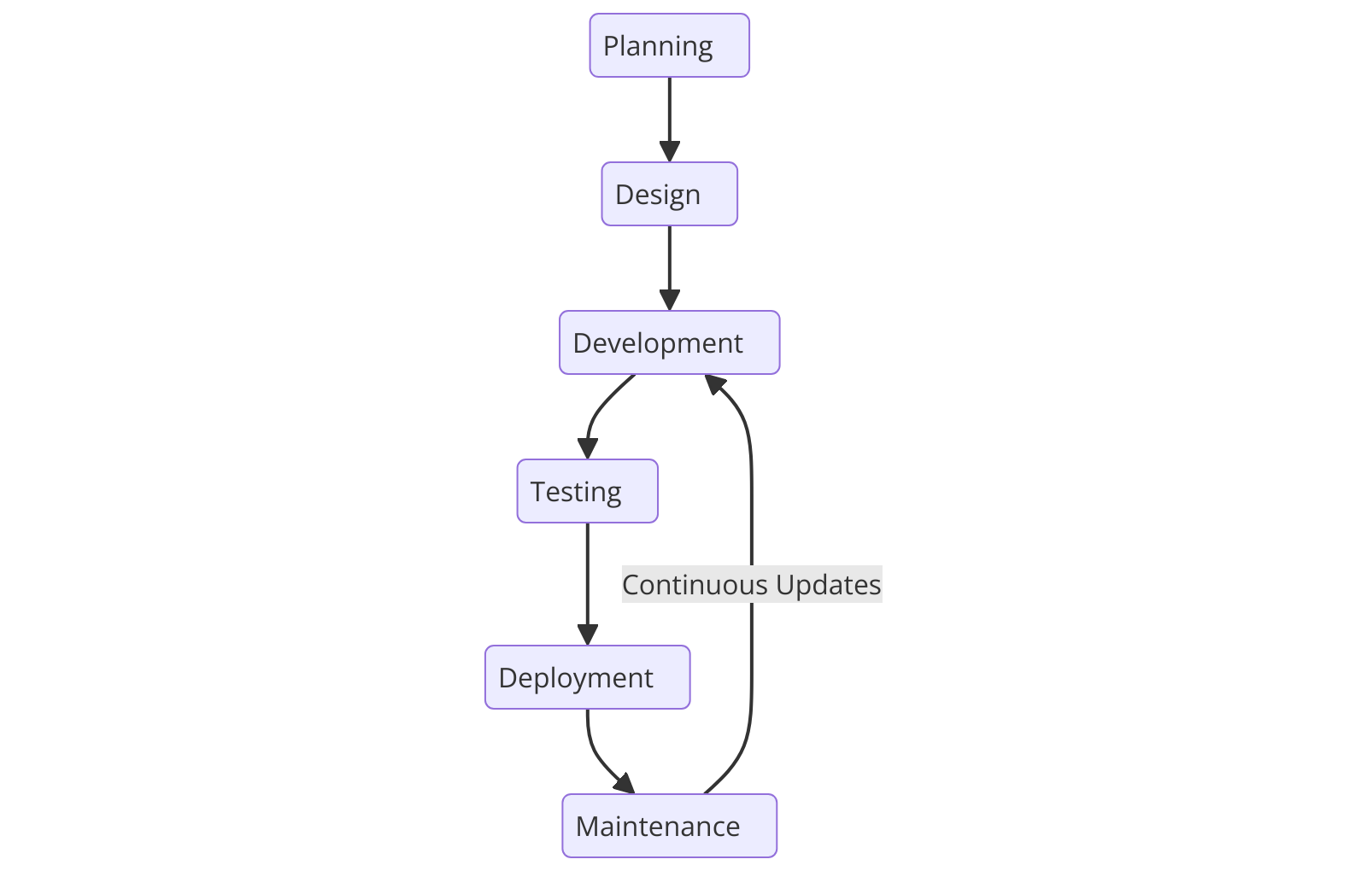Figure 3.1 Agile SDLC Diagram

3.3 Programming Environment

* Operating System: Windows 10 / macOS / Linux
* Code Editor: Visual Studio Code
* Frontend Technologies: EJS, Tailwind CSS
* Backend Technologies: Node.js, Express.js
* Database Management: PostgreSQL (pgAdmin for GUI management)
* Version Control: Git & GitHub
* Hosting: Potentially using Heroku or AWS for deployment

**3.4 Functional Requirements**

**3.4.1 Hardware Requirements**

To develop and deploy ProConnect, the following hardware specifications are required:

|  |  |  |
| --- | --- | --- |
| **Component** | **Minimum Specification** | **Recommended Specification** |
| **Processor** | Intel Core i5 / AMD Ryzen 5 | Intel Core i5 / AMD Ryzen 5 |
| **RAM** | 8GB | 16GB or higher |
| **Storage** | 256GB SSD | 512GB SSD or higher |
| **Internet Connection** | Broadband | High-speed fiber optic |

**3.4.2 Software Requirements**

|  |  |  |
| --- | --- | --- |
| **Software** | **Version** | **Purpose** |
| Node.js | v18+ | Backend development |
| Express.js | Latest | Web framework |
| EJS | Latest | Templating engine |
| Tailwind CSS | v3+ | UI styling |
| PostgreSQL | v14+ | Database |
| pgAdmin | v6+ | Database management |
| Git | Latest | Version control |
| VS Code | Latest | Code editor |

**3.5 Non-Functional Requirements**

1. Scalability – The system should handle multiple users simultaneously without performance degradation.
2. Security – User authentication via Cookies and Sessions to prevent unauthorized access.
3. Reliability – Ensures high uptime with error handling mechanisms in place.
4. Performance – Optimized API calls and database queries for fast response times.
5. Usability – Intuitive UI for easy navigation, ensuring a seamless user experience.

**3.6 Procedure for Installation of Software**

**Step-by-Step Guide**

1. Install Node.js and NPM

* Download Node.js from Node.js official site and install it.
* Verify installation by running:

node -v

npm –v

1. Set Up PostgreSQL & pgAdmin

* Download PostgreSQL from PostgreSQL official site and install it.
* Set up a new database and configure pgAdmin for management.

1. Install Git and Clone Repository

* Install Git from Git official site.
* Clone the project:

git clone <repository-url>

cd proconnect

1. Install Required Packages

* Navigate to the project folder and install dependencies

1. Run the Application

* Start the Node.js server

1. Deploy to Cloud (Optional)

* Use Heroku, AWS, or Vercel for hosting.

**3.7 Ethical Considerations**

1. Data Privacy and Protection

* Users' personal and financial data are encrypted and stored securely. Compliance with General Data Protection Regulation (GDPR) and data protection laws.

1. Fair Usage Policy

* Transparent policies ensuring fair treatment of both companies and professionals.

1. Prevention of Exploitation

* ProConnect ensures fair pay by tracking hours and enforcing payment protection measures.

1. Accessibility and Inclusivity

* The platform is designed with accessibility features to accommodate users with disabilities.

**CHAPTER 4**

**IMPLEMENTATION AND RESULTS**

**4.1 Introduction**

This chapter focuses on the implementation process of the ProConnect platform, detailing how the system was developed and how it operates. The chapter provides an in-depth discussion of the software’s functionalities, including the overall purpose, step-by-step implementation, and the results obtained.

First, a broad description of the application will be given, outlining its core features and how it fulfills the objectives set in previous chapters. Then, the implementation process will be explained through a step-by-step guide, demonstrating how different stakeholders interact with the system. Each feature will be illustrated with labeled snapshots of the actual application outputs to show its working mechanism.

Finally, the results of the implementation will be analyzed, discussing how well the developed platform meets its intended purpose, ensuring efficient and structured interactions between companies and professionals. The chapter will highlight how time tracking, job posting, hiring, and payment security mechanisms enhance transparency and reliability in freelance engagements.

This chapter serves as the practical validation of the ProConnect system, demonstrating how it operates and the extent to which it satisfies the outlined objectives.

**4.2 Broad Description of the Application**

The ProConnect platform is a web-based service network designed to facilitate secure and structured interactions between companies (clients) and professionals (freelancers). It provides an efficient environment where companies can post job opportunities, track work progress, and process payments, while professionals can apply for jobs, log working hours, and receive payments securely.

The platform addresses key challenges in the freelance economy, such as:

1. Skill Verification – Ensuring that professionals are qualified through profile validation.
2. Job Continuity – Providing freelancers with consistent work opportunities.
3. Work Tracking – Implementing a time-tracking system to ensure fair compensation.
4. Payment Security – Introducing conditional withdrawals based on tracked work hours.

**4.2.1 Core Functionalities of ProConnect**

1. User Management & Authentication

* Two user categories: Companies and Professionals
* Secure login system using Cookies and Sessions for authentication
* Profile creation with skill verification for freelancers

1. Job Posting & Application System

* Companies can create and manage job listings
* Professionals can browse available jobs and submit applications
* Companies review applications and select suitable candidates

1. Time-Tracking & Work Monitoring

* Companies can track progress and verify completed hours based on job detail
* Ensures transparency and prevents disputes

1. Payment & Withdrawal Module

* Payments where both parties (companies and professionals) agree on the status of payment before payment confirmation
* Conditional withdrawal system ensures freelancers receive secure payments

1. Admin Dashboard

* Admins can approve and reject users.
* Ensures regulatory compliance and quality control

**4.2.2 How ProConnect Achieves Its Purpose**

1. For Companies:

* Easily post job listings and find skilled professionals.
* Specify freelancer worth of work hours and ensure work accountability.
* Secure payment process with verification mechanisms.

1. For Professionals:

* Apply for verified job listings and get consistent freelance work.
* Log hours transparently and get paid based on actual work done.
* Request payment by providing bank details and confirming status of paymnet before job completion.

The ProConnect platform creates a structured and transparent freelance marketplace where companies and professionals can engage efficiently. By addressing trust issues, job continuity, and payment security, ProConnect ensures a seamless freelance experience while promoting professionalism in the gig economy.

**4.3 Implementation of the Application**

This section provides a step-by-step implementation guide for the ProConnect platform, covering both Company and Professional user roles, along with Admin functionalities. Each step outlines what happens in the system with a visual represemtation.

**4.3.1 Landing Page and User Registration**

Step 1: Accessing the Landing Page

* When users visit the ProConnect platform, they see a landing page that introduces the application and its purpose.
* From this page, users can choose to sign up as a Professional or a Company.

Figure 4.1 Landing Page

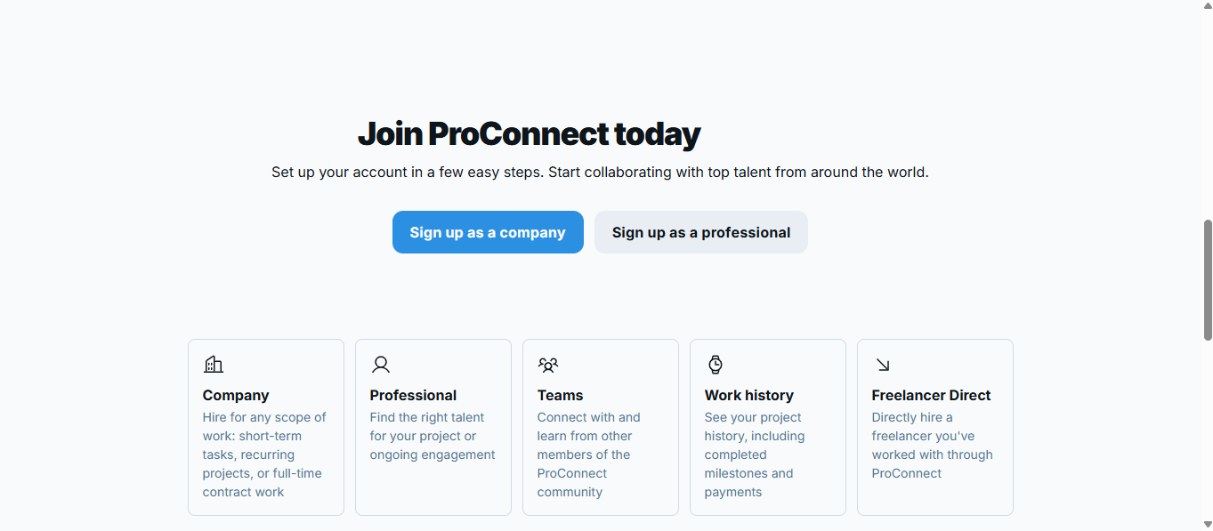Figure 4.2 Landing Page

Step 2: User Registration (Company or Professional)

* Users must fill out a registration form to create an account.
* Companies provide business details, while professionals submit qualifications and skills.

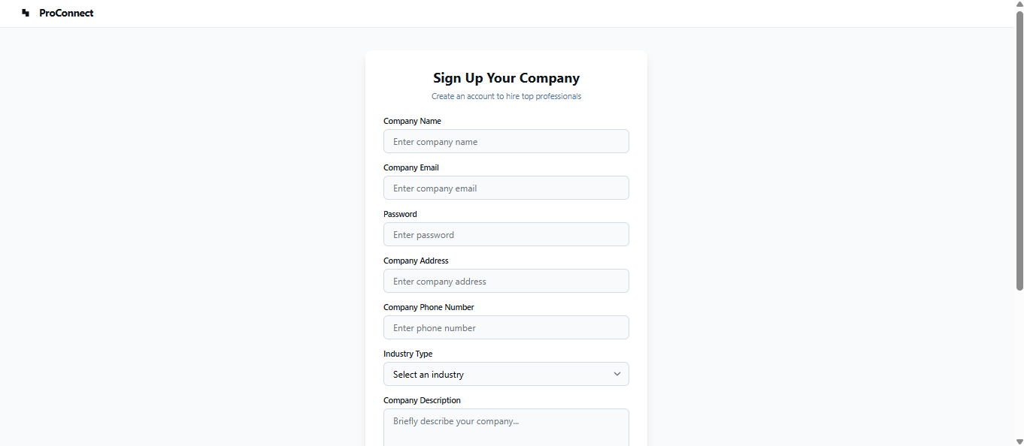Figure 4.3 Company Sign Up Page

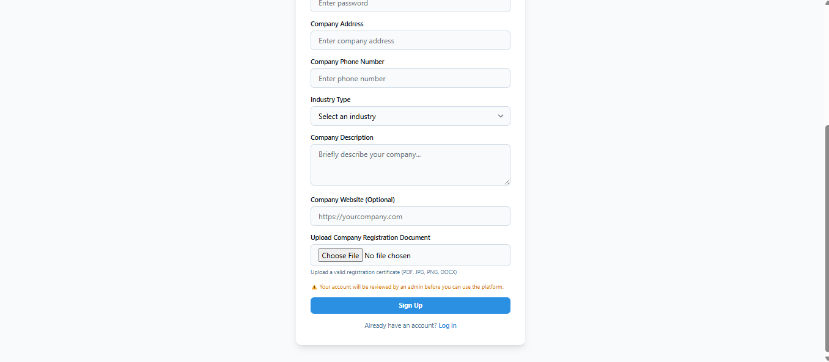Figure 4.4 Company Sign Up Page

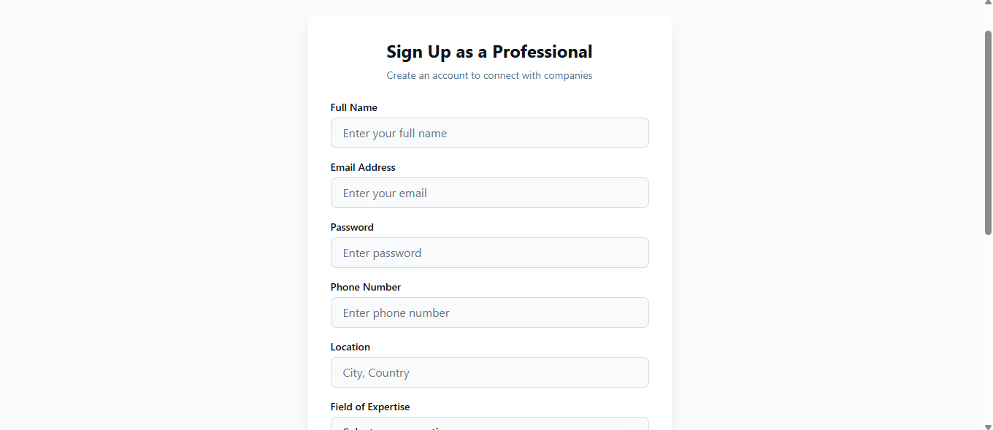Figure 4.5 Professional Sign Up Page

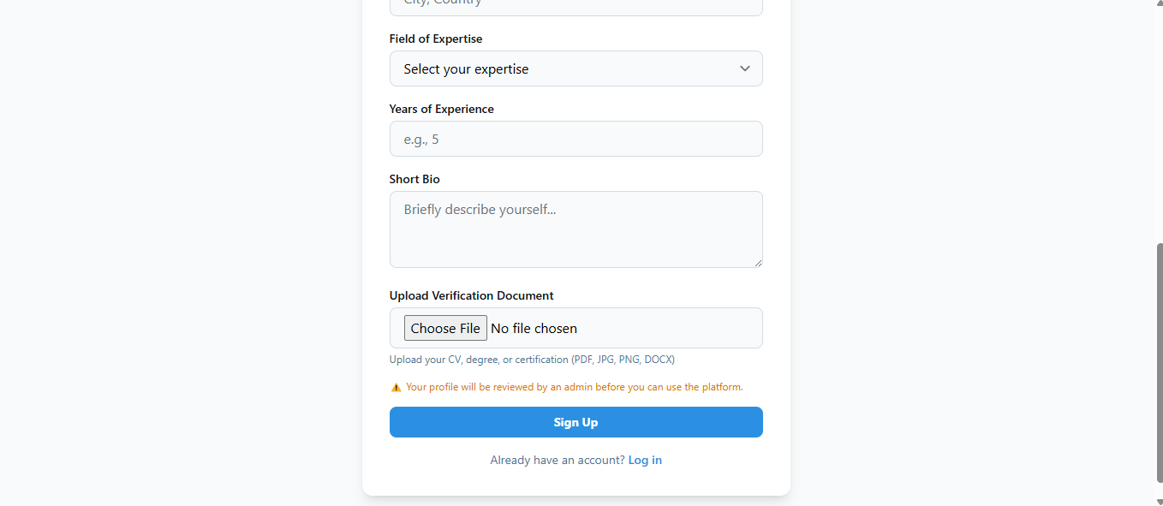Figure 4.6 Professional Sign Up Page

Step 3: Admin Review & Approval

* After signing up, users cannot log in until an admin reviews and approves their accounts.
* The admin panel lists all pending registrations for verification.
* Once approved, users can proceed to log in.

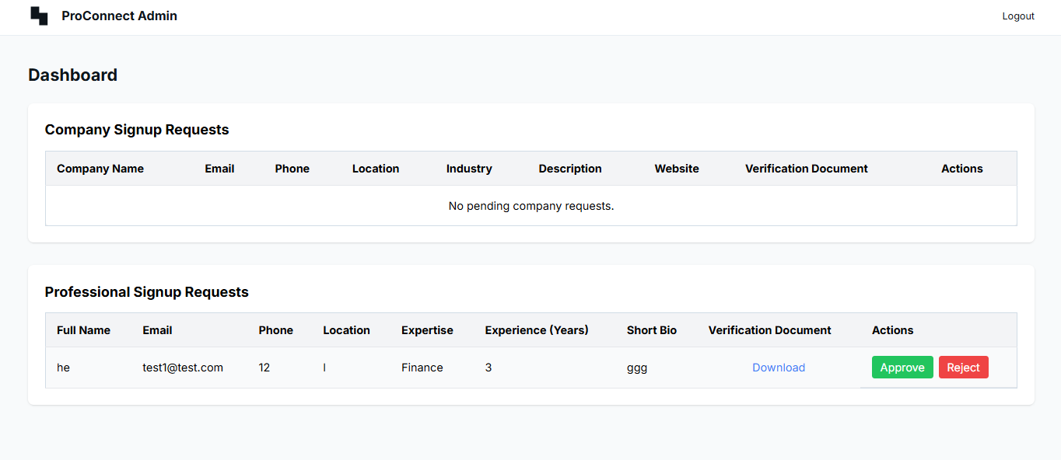Figure 4.7 Admin User Approval Page

**4.3.2 User Login and Dashboard**

Step 4: Login Process

* Approved users enter their email and password to access the system.
* If login is successful, users are redirected to their respective dashboards based on their role (Company or Professional).

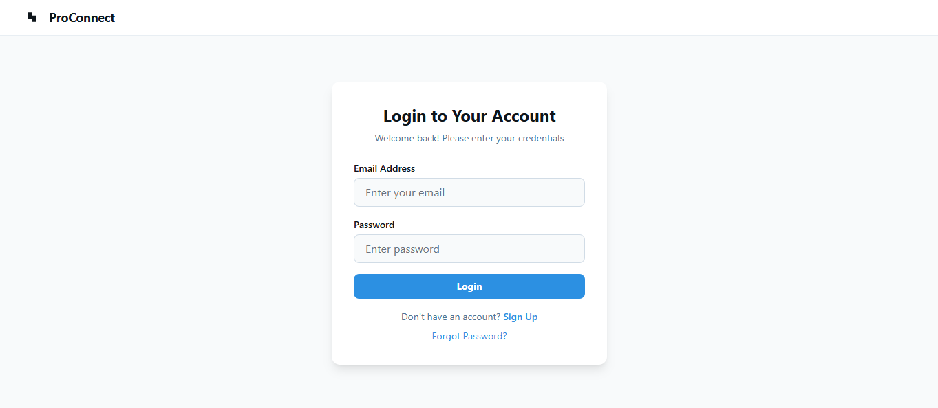Figure 4.8 Login Page

**4.3.3 Company-Side Functionalities**

Step 5: Company Dashboard

* Once logged in, companies land on their dashboard, which displays statistics on the platform, such as:
  + Number of jobs posted
  + Total amount of pending payments
  + Number of completed jobs

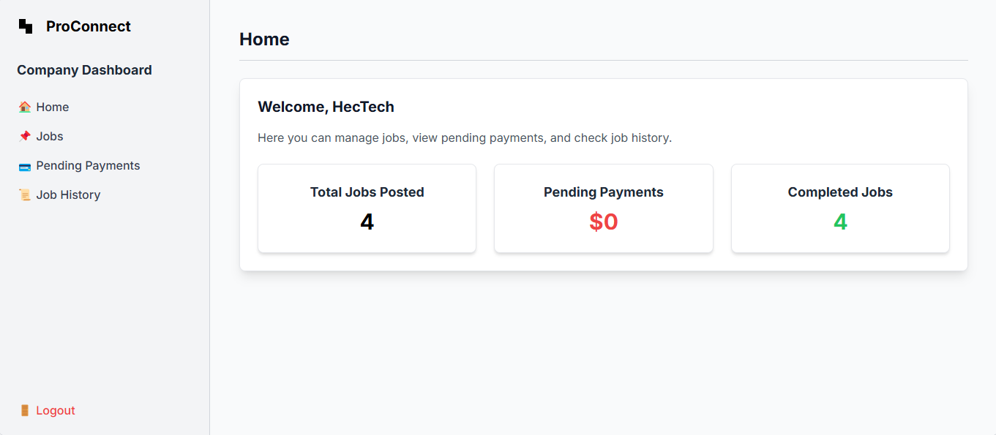Figure 4.9 Company Home Page

Step 6: Viewing and Posting Jobs

* Companies navigate to the Jobs Page where they can:
  + View all job postings
  + Create new job listings, including job title, description, payment terms, total work time of jobs.
  + Manage applications

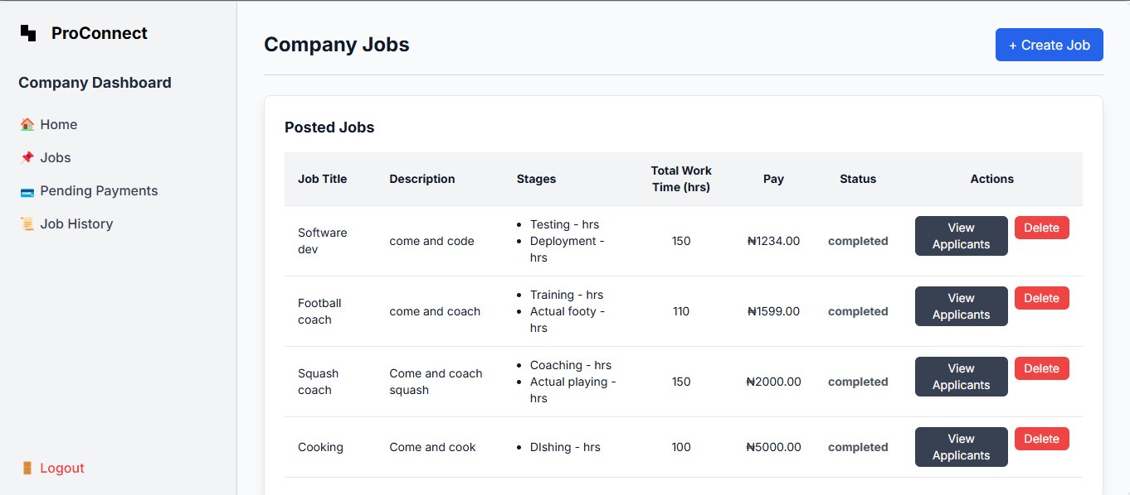Figure 4.10 Job Posting and Job List Page

Step 7: Managing Pending Payments

* The Pending Payments Page displays:
  + Professionals who have requested payment for completed jobs.
  + Bank details of professionals.
  + Job details for verification.
* Companies can mark payments as completed after verification.

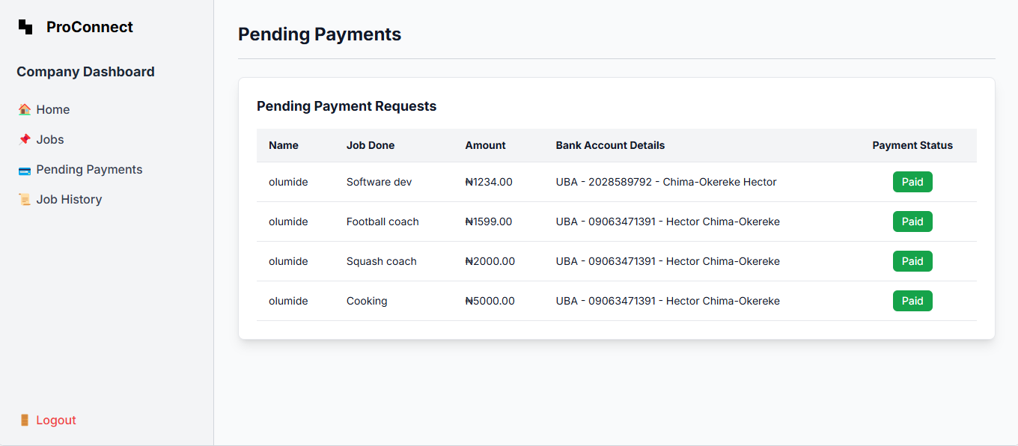Figure 4.11 Pending Payments Page

Step 8: Viewing Completed Jobs Companies can access a record of fully completed jobs, ensuring a structured view of past engagements.

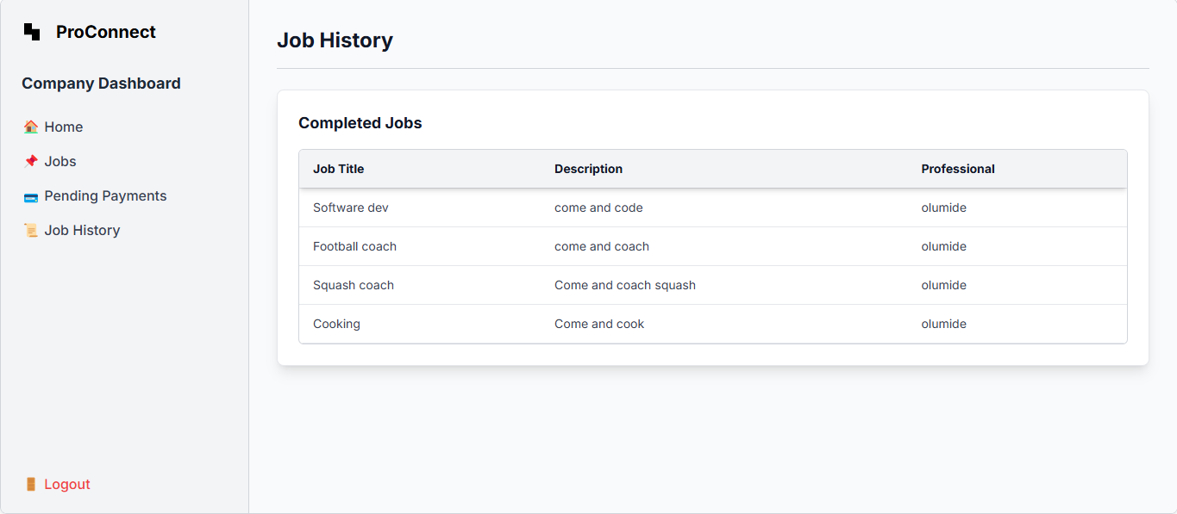Figure 4.12 Completed Jobs Page (Company Side)

**4.3.4 Professional-Side Functionalities**

Step 9: Professional Dashboard

* Once logged in, professionals land on their dashboard, which displays:
  + Number of jobs enrolled in
  + Total amount of pending payments
  + Completed job statistics
  + Total Worth of Hours Worked

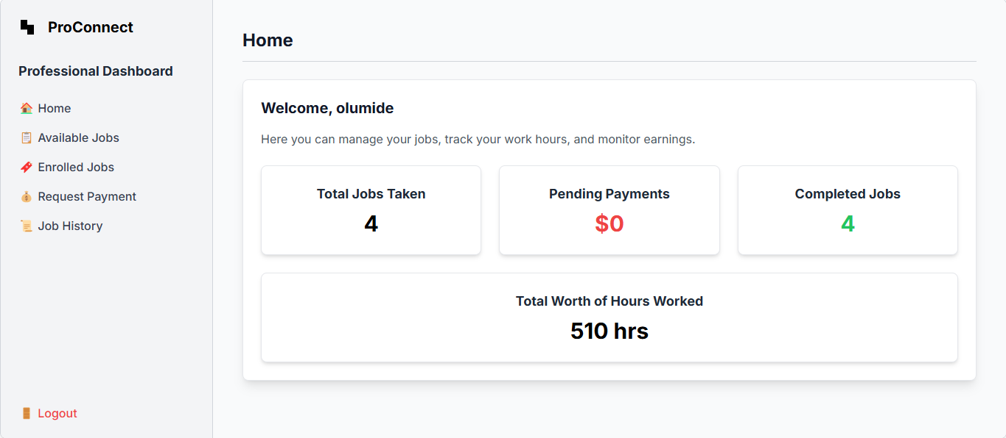Figure 4.13 Professional Dashboard Page

Step 10: Viewing and Applying for Jobs

* Professionals navigate to the Jobs Page, where they can:
  + View available jobs posted by companies.
  + Apply for jobs by submitting a proposal.

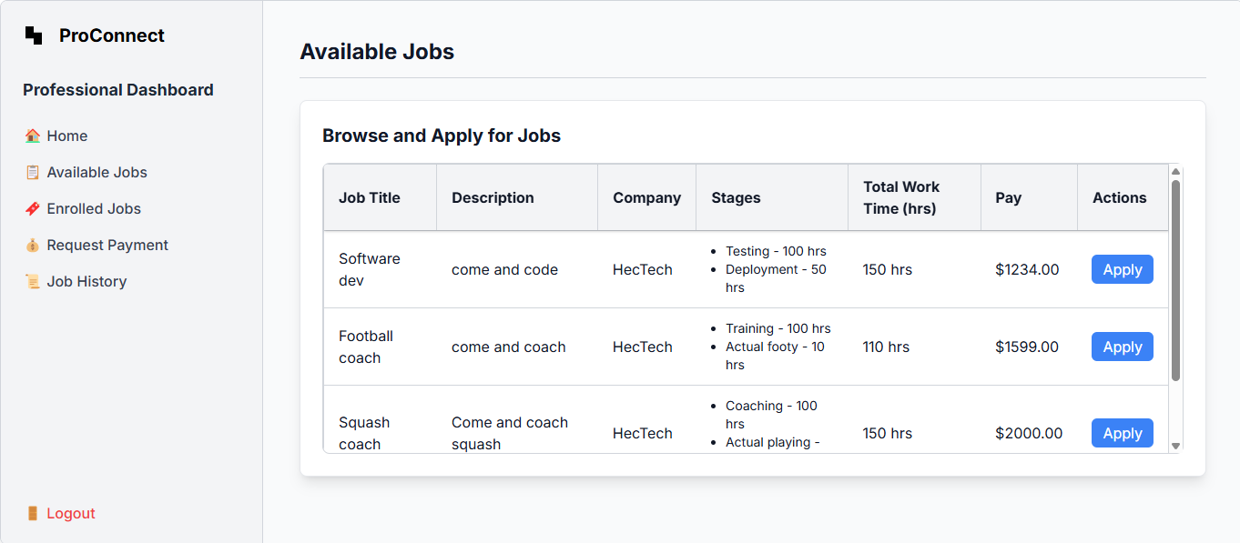Figure 4.14 Job Listings and Application Page

Step 11: Managing Accepted Jobs

* Professionals can view jobs they have been accepted for by companies.
* They can update job status as work progresses.

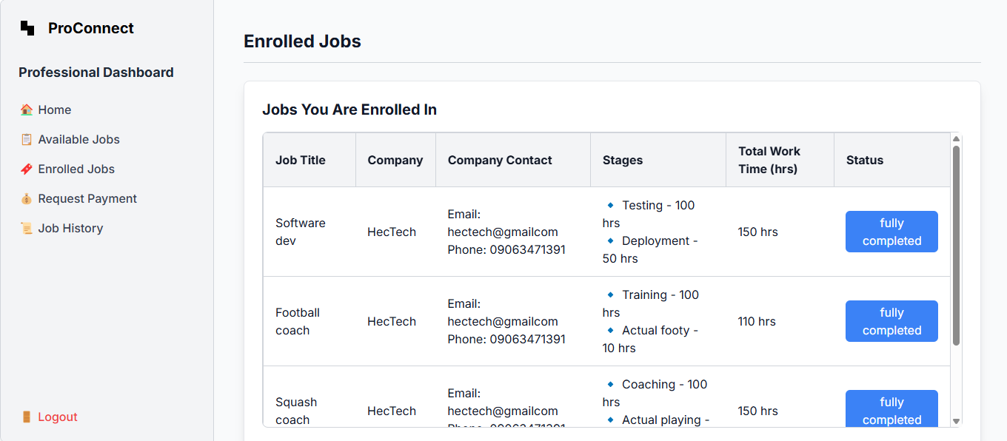Figure 4.15 Accepted Jobs Page

Step 12: Requesting Payment for Completed Jobs

* Once a job is completed, professionals move it to the "Awaiting Payment" section.
* They submit bank details and request payment.
* They can mark jobs as paid once they receive their payment.

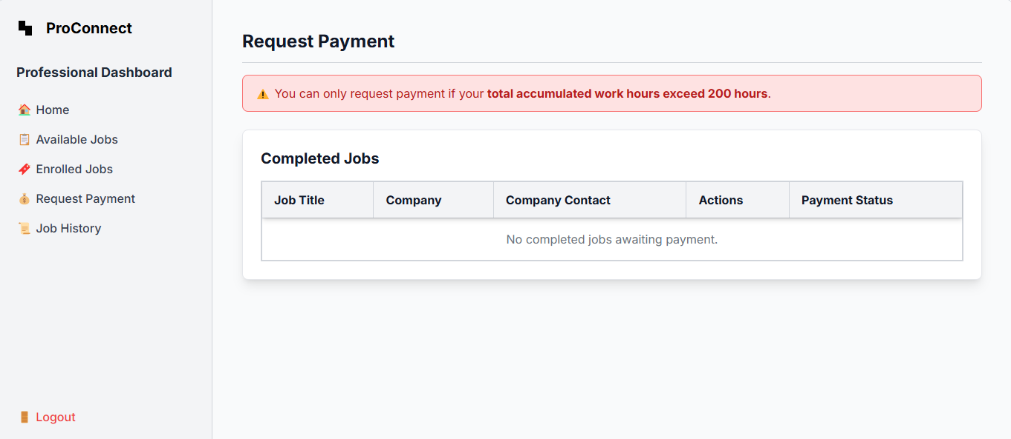Figure 4.16 Payments Requests Page

Step 13: Viewing Completed Jobs

* Professionals can access records of fully completed jobs, keeping track of past engagements.

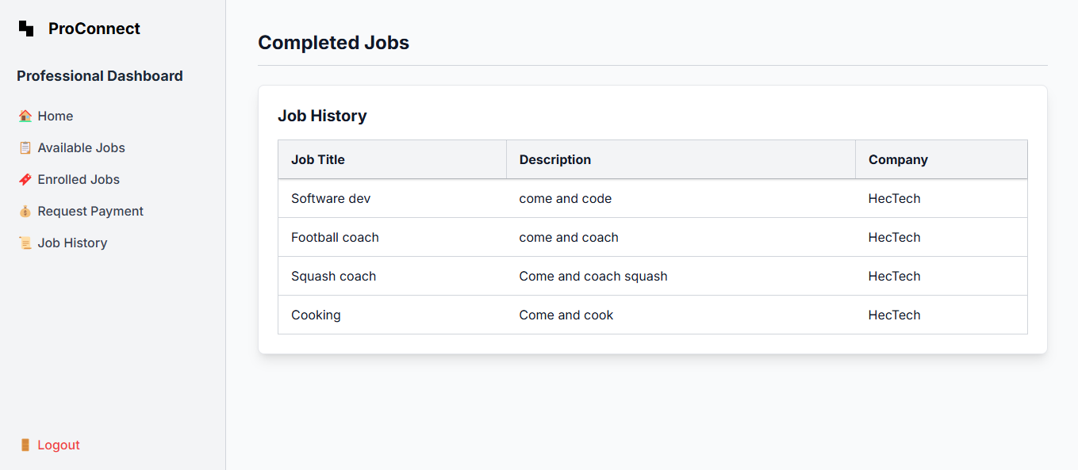Figure 4.17 Completed Jobs Page (Professional Side)

**4.4 Results**

The ProConnect platform successfully implements a structured and transparent service network for companies and professionals, addressing key challenges in the freelance economy such as job continuity, skill verification, work tracking, and payment security. Below is a summary of the significance of each output obtained from the implementation process (referencing snapshots from 4.3):

**4.4.1 User Registration and Approval** **(Figures 4.1 – 4.7)**

Significance:

* The Landing Page effectively introduces users to the platform and directs them to register as either Companies or Professionals.
* The Registration Process ensures that all users provide necessary credentials, making the platform secure and professional.
* The Admin Review System prevents unauthorized users from accessing the platform, enhancing trust and authenticity among users.

**4.4.2 User Login and Dashboard (Figure 4.8 - 4.9 & 4.12)**

Significance:

* The Login Page allows only approved users to access the system, ensuring restricted access for security.
* The Company and Professional Dashboards provide a clear overview of activities, helping users easily track their jobs, applications, and progress.

**4.4.3 Company Functionalities**

Viewing and Posting Jobs (Figure 4.10)

Significance:

* The Job Posting Feature allows companies to create job listings, ensuring a structured hiring process.
* The Application Management System makes it easy for companies to review applicants and hire the best talent, improving efficiency in the selection process.

Managing Payments (Figure 4.11)

Significance:

* The Pending Payments Page ensures transparent and secure payments by displaying details of completed jobs and professionals' bank details.
* Companies can verify work done before processing payments, reducing payment fraud and ensuring fair compensation.
* The Completed Jobs Section allows companies to keep a record of all past engagements, aiding in financial tracking and job management.

**4.4.4 Professional Functionalities**

Applying for Jobs and Managing Accepted Jobs (Figures 4.14 & 4.15)

Significance:

* The Job Listings Page provides professionals with access to various job opportunities, ensuring continuous work availability.
* The Accepted Jobs Page allows professionals to track projects they’ve been hired for, ensuring better organization and time management.

Payment Requests and Completed Jobs (Figure 4.16)

Significance:

* The Payment Request System gives professionals a secure and structured way to request their earnings, preventing delayed or unfair payments.
* The ability to mark jobs as paid enhances financial transparency between companies and professionals.
* The Completed Jobs Section helps professionals track their work history, useful for future applications and portfolio building.

**4.4.5 Overall Impact of the Implementation**

The successful implementation of ProConnect demonstrates that the system effectively:

* Provides a secure platform for companies to find verified professionals.
* Ensures structured work tracking through time-based job management.
* Offers a transparent payment process, reducing freelance payment issues.

By integrating these features, ProConnect enhances the reliability, efficiency, and security of freelance engagements, making it a valuable solution in the digital service economy.

**CHAPTER 5**

**SUMMARY, CONCLUSION, AND RECOMMENDATIONS**

**5.1 Summary**

This project focused on the development of ProConnect, a service network platform designed to facilitate structured interactions between companies and freelance professionals. The platform aimed to address key challenges in the freelance industry, such as skill verification, job continuity, work tracking, and payment security.

The system was implemented as a web-based platform, leveraging technologies such as Node.js, Express.js, Embedded JavaScript (EJS), Tailwind CSS, and PostgreSQL. It provides companies with the ability to post jobs, hire professionals, track work progress, and manage payments, while professionals can apply for jobs, log their work hours, and receive payments securely.

The methodology followed in this project included the Agile Software Development Life Cycle (SDLC), allowing for an iterative approach in implementing user authentication, job management, time tracking, and payment functionalities. Testing and evaluation confirmed that the platform effectively enhances accountability, transparency, and efficiency in freelance work management.

**5.2 Conclusion**

The ProConnect platform successfully met the project’s primary objective of creating a structured and secure freelance marketplace. The specific objectives outlined in Chapter 1 were achieved as follows:

Objective 1: To create a platform where companies can advertise job opportunities and professionals can apply

* Implemented a job posting and application system, allowing seamless hiring processes.

Objective 2: To implement a time-tracking system that records professionals’ work hours accurately

* Integrated a time-tracking mechanism, ensuring fair and transparent payment based on logged work hours.

Objective 3: To establish a verification process for assessing the skills and credentials of applicants

* Introduced an admin approval system, ensuring that only verified professionals can access job postings on the platform.

Overall, ProConnect provides a secure, reliable, and efficient platform that bridges the gap between companies and professionals, fostering trust and structured work engagement.

**5.3 Recommendations for Future Research**

While this project successfully implemented a functional and secure freelance service network, some limitations were encountered that present opportunities for future research and development:

1. AI-Powered Job Matching

* Currently, job applications are manual, where professionals browse listings and apply.
* Future research could implement AI-driven job recommendations based on skill matching, past job history, and freelancer ratings.

1. Automated Payment Processing

* Payments are currently manually approved by companies.
* Future enhancements could integrate automated payment processing using blockchain or smart contracts to ensure instant and secure transactions.

1. Mobile Application Development

* ProConnect is currently a web-based platform.
* Future work could focus on developing a mobile application to improve accessibility and user engagement.

1. Advanced Dispute Resolution System

* The current dispute resolution is admin-managed.
* Future improvements could introduce an AI-driven dispute resolution system, ensuring faster conflict resolution between companies and professionals.

1. User Rating & Review System

* Currently, ProConnect does not include a rating and review feature.
* Future enhancements should allow users to rate companies and professionals based on performance, fostering credibility and reputation-building.

**Final Thoughts**

This research has provided a strong foundation for structured and secure freelance work management. By addressing key limitations and exploring future improvements, ProConnect can evolve into a fully automated, AI-powered, and scalable platform, making it a leading solution in the gig economy.

**References**

1. Meijerink, J., & Keegan, A. (2019). Conceptualizing human resource management in the gig economy: Toward a platform ecosystem perspective. Journal of Managerial Psychology, 34(4), 214-232. <https://www.researchgate.net/publication/331064144_Conceptualizing_human_resource_management_in_the_gig_economy_Toward_a_platform_ecosystem_perspective>
2. Schor, J. B. (2020). After the gig: How the sharing economy got hijacked and how to win it back. University of California Press. <https://www.ucpress.edu/books/after-the-gig/paper>
3. Stephany, A. (2021). The business of platform economies: Markets, monetization, and competition. Oxford University Press.
4. Vallas, S. P., & Schor, J. B. (2020). What do platforms do? Understanding the gig economy. Annual Review of Sociology, 46(1), 273-294. <https://www.researchgate.net/publication/340823562_What_Do_Platforms_Do_Understanding_the_Gig_Economy>
5. Wood, A. J., Graham, M., Lehdonvirta, V., & Hjorth, I. (2019). Good gig, bad gig: Autonomy and algorithmic control in the global gig economy. Work, Employment and Society, 33(1), 56-75. <https://psycnet.apa.org/record/2019-07886-004>